Pure H2 to production by decomposition of methane over nickel supported on hydroxyapatite catalysts

One method of methane decomposition currently relies on a nickel catalyst, supported by compounds such as TiO2, MgO, ZrO2, A.l2O3. The rate of reaction depends on the Ni particle size, with both relation to the dispersion and stabilisation by a suitable support. [x]

J. Ashok, S Naveen. Kumar, M. Subrahmanyam, A. Venugopal, have been looking at how a new nickel catalyst support, hydroxyapatite (HAp), and how it will affect this reaction. HAp is produced from Ca5(NO3)4 ∙ 4H2O and (NH4)(PO3OH) to make [Ca5(PO4)3(OH)] while under basic conditions.[x]

Unlike the previously mentioned catalyst supports, HAp is irreducible; this means no CO is made in the reaction unlike the other supports currently in use, meaning the reaction has a simple overall equation with no greenhouse gas (GHGs) emissions:

CH4 🡪 C +2H2

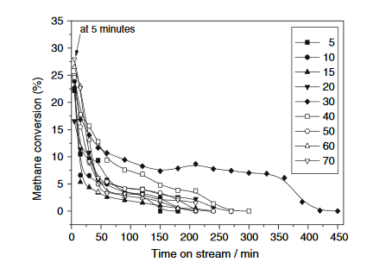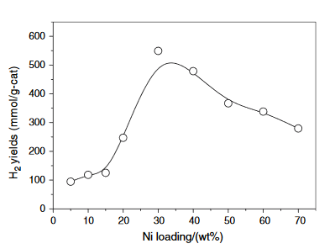This reaction has an enthalpy of 75.6 JK mol-1 meaning it is endothermic. In the experiment performed by J. Ashok et al. the experiment was run at just 650 oC [x] , as this is an endothermic reaction these operating condition are fairly mild. The CH4 should be flowed through the reaction chamber at a fairly slow 24 L hour-1 [x] again meaning no extra energy is needed to accelerate the gas. These combined factors and the lack of (GHGs) produced make this reaction both green and sustainable.

FIG. Y how the %wt of Ni loaded on the catalyst affects H2 production over time.[x]

FIG. X how the %wt of Ni loaded on the catalyst supports affects the yield of H2.[x]

As you can see from Fig. X a 30 wt% Ni sample was the optimum for this reaction. It has both the highest yield and the best durability. This reaction does have one major draw back however in that the catalyst does readily degrade. This means the solid waste carbon, which is responsible for the deactivation of the catalyst, will be contaminated with toxic Ni atoms.

This is a very promising technology which warrants further research, as it can help to solve the current H2 crisis.

J. Ashok, S Naveen. Kumar, M. Subrahmanyam, A. Venugopal, *Catalysis letters*, 2008, **121 (3)**, 283-290